Alien Language



In this project you will train the computer to understand an alien language.

You’ll use that to control an alien character so that it can understand what you tell it to do.

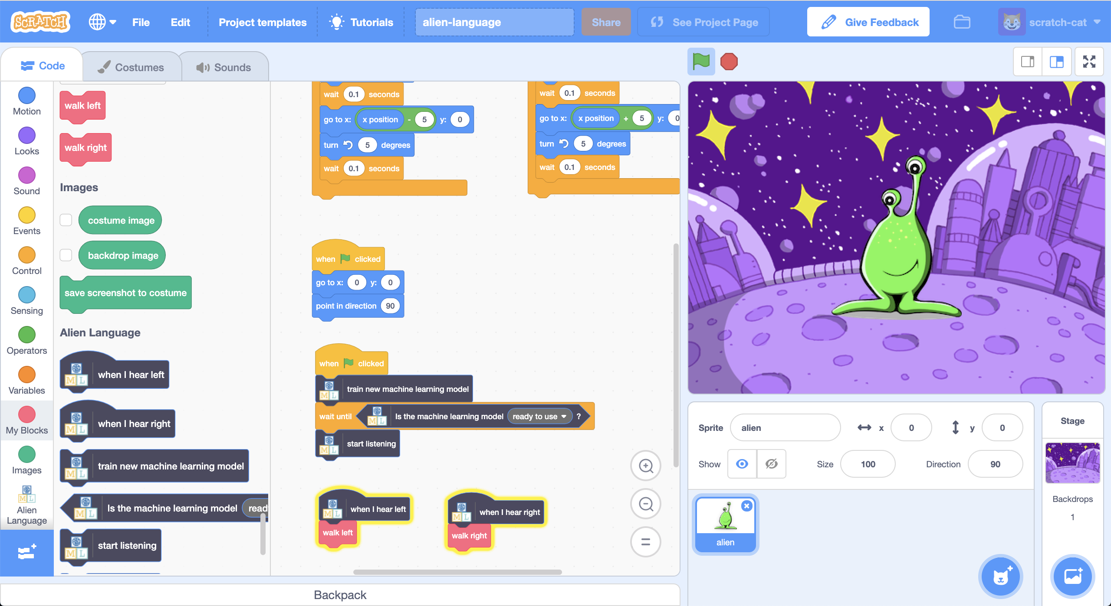

This project worksheet is licensed under a Creative Commons Attribution Non-Commercial Share-Alike License

http://creativecommons.org/licenses/by-nc-sa/4.0/

This project requires a **microphone**. If you don’t have a computer with a microphone, you might prefer to try a different worksheet.

1. Go to <https://scratch.machinelearningforkids.co.uk/>

The next few steps only work with **Google Chrome**.

If you don’t have access to Google Chrome, skip to **step 5** and start from there.

1. Load the **Speech to Text** extension  
   *Click on the Extensions (plus) button in the bottom left, and then choose Speech to Text from the list.*   
   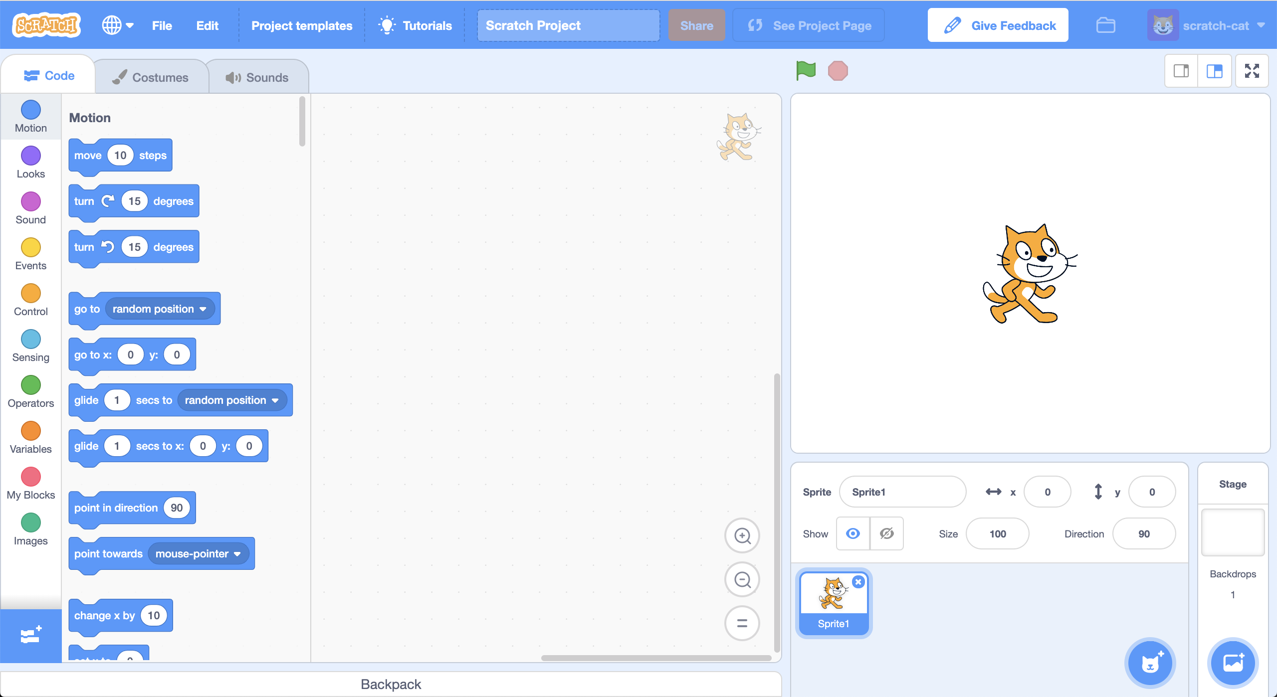
2. Using the new Speech to Text blocks, create the following scripts.  
   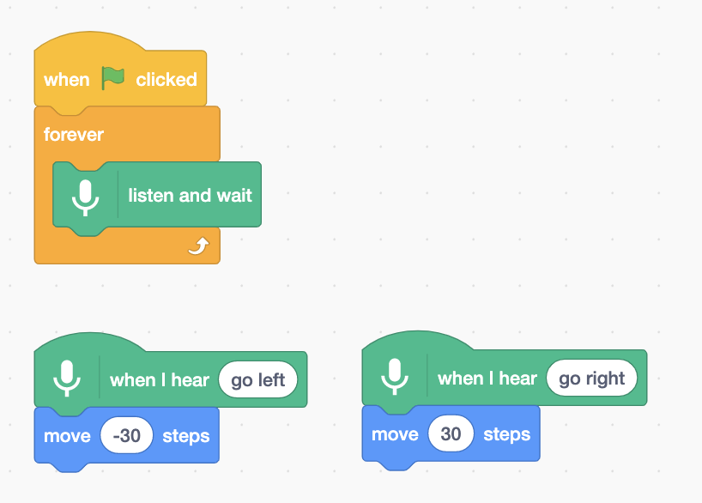
3. Click on the **Green Flag** and give it a try  
   *Say “left” or “right”. The cat should move in the direction that you tell it to. Try and move it back and forth across the screen using your voice.   
   It can be difficult to get it to work. Try to speak calmly and clearly.  
   If it doesn’t work, modify your script to show what it thinks you’re saying:*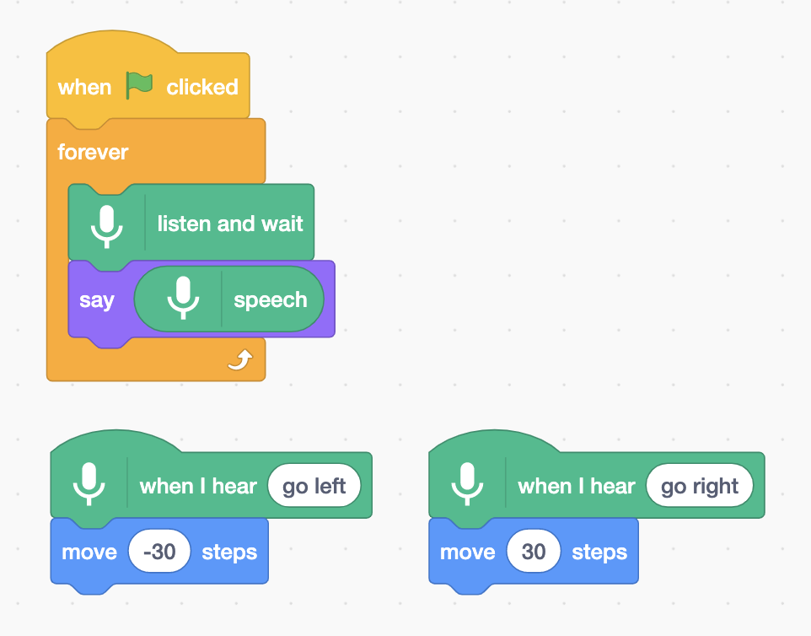

**What have you done so far?**

You’ve used **speech recognition** to control a character in Scratch. To get this working quickly, you’ve used a machine learning model that has already been trained for you. This is a general machine learning model that has been trained to recognize English dictionary words.

Next, you’ll train a machine learning model for yourself to see how it was done.

For the next part of the project, you’ll use your voice to control an alien character that doesn’t understand English! You’ll invent two new words, that wouldn’t be found in an English dictionary, to control your character and train a machine learning model to recognize them.

1. Invent your alien language!  
   You need two words – an alien word for “left” and an alien word for “right”. Invent new words that wouldn’t show up in an English dictionary. They can be random noises as long as you can repeat them in the same way every time and will be recognisably different from each other.   
   If you don’t want to make weird noises with your voice, that’s okay - find other ways to make noises. You can click your fingers, clap your hands, squeeze a squeaky toy or do anything else you can think of!
2. Go to <https://machinelearningforkids.co.uk/>
3. Click on “**Log In**”
4. Click on “**Try it now**”
5. Click on “**Projects**” on the top menu bar
6. Click the **“+ Add a new project**” button.
7. Name your project “Alien Language” and set it to learn how to recognise “**sounds**”.   
   Click the “**Create**” button  
   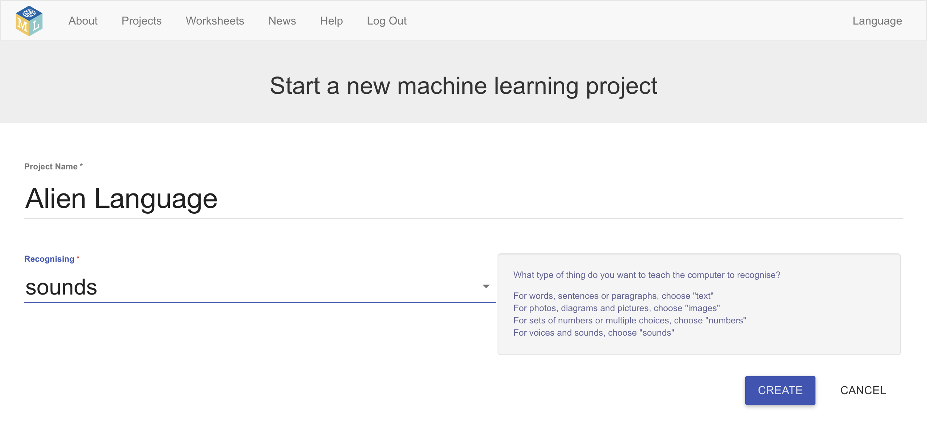
8. You should now see “**Alien Language**” in the list of your projects. Click on it.
9. Click on the **Train** button to start collecting examples.
10. Click on the **Add example** button in the **background noise** bucket  
    *Recording background noise will help your machine learning model to tell the difference between the sounds you will train it to recognize, and the background noise where you are.*  
    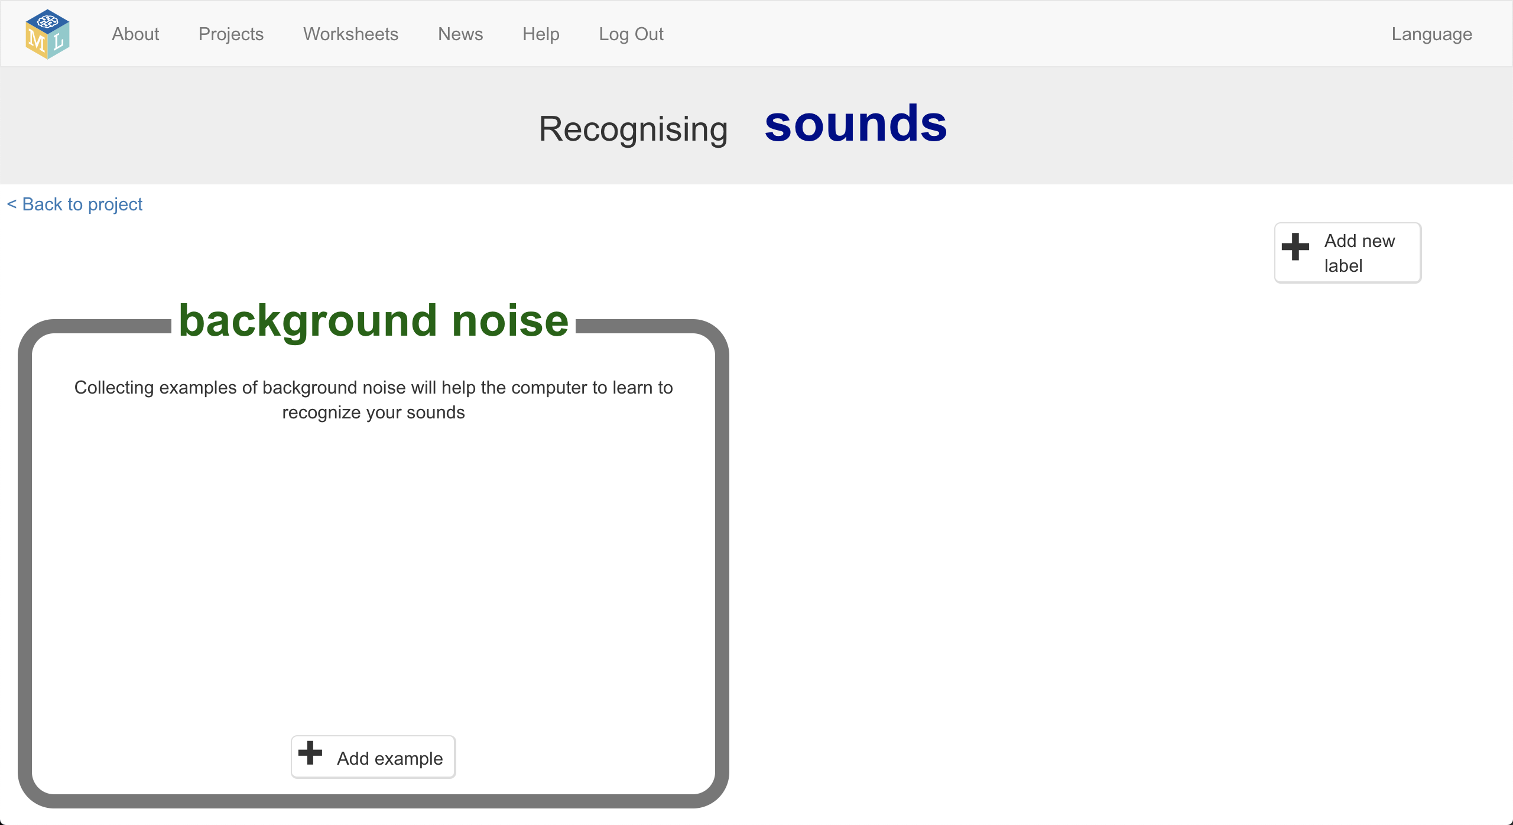
11. Click the **microphone** to record 2 seconds of background noise  
    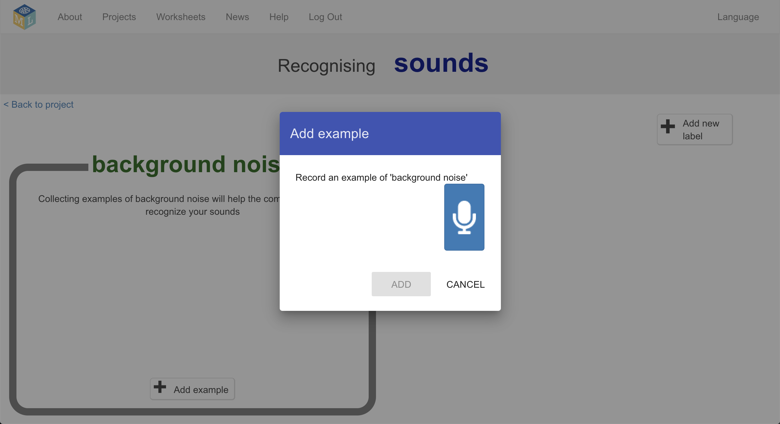
12. Click the **Add** button to save your recording   
    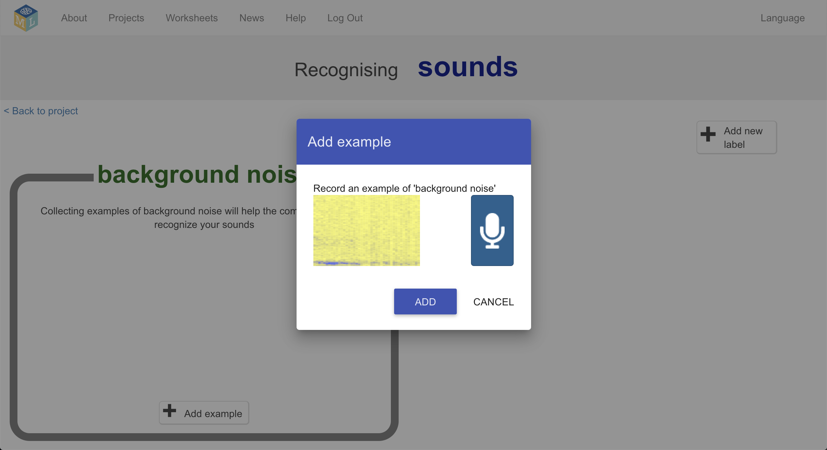
13. Repeat that until you have **at least 8** examples of background noise  
    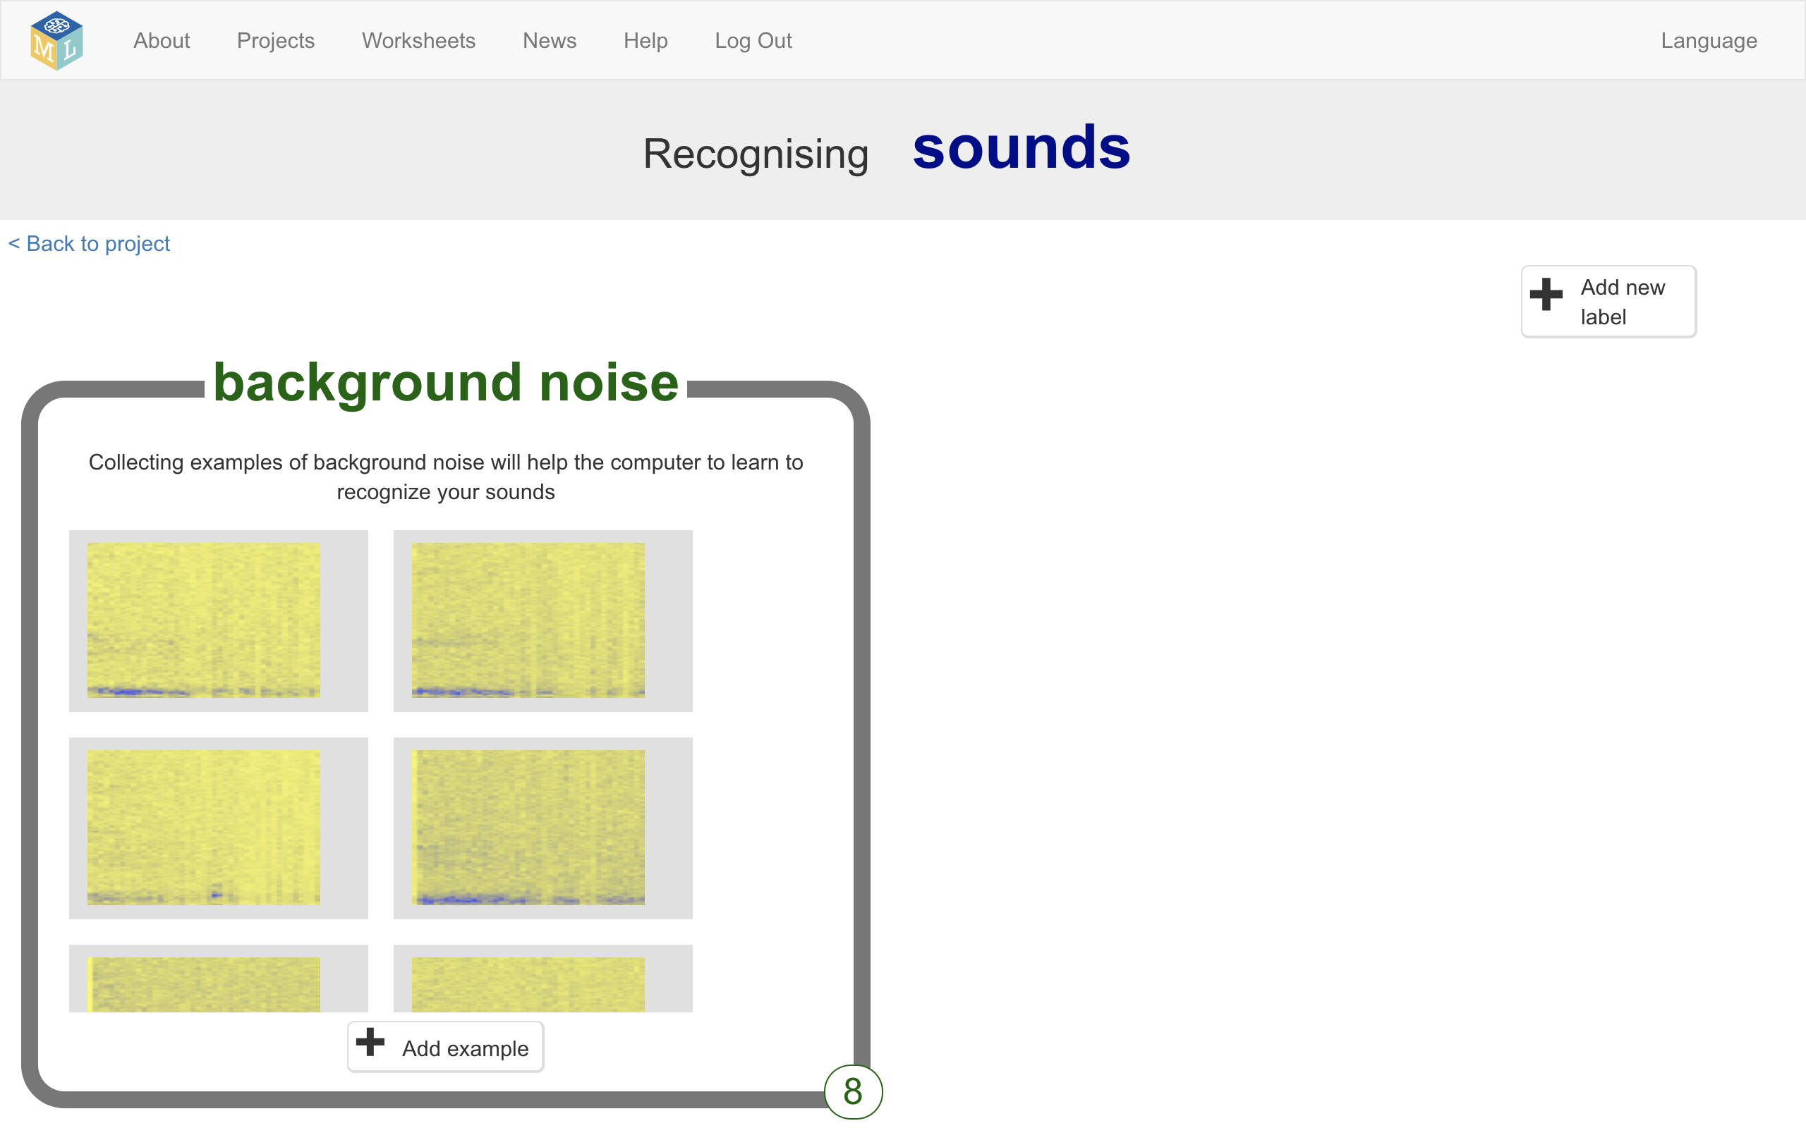
14. Click the **Add new label** button in the top right, and create a new training bucket called “left”
15. Click the **Add example** button in the new left bucket  
    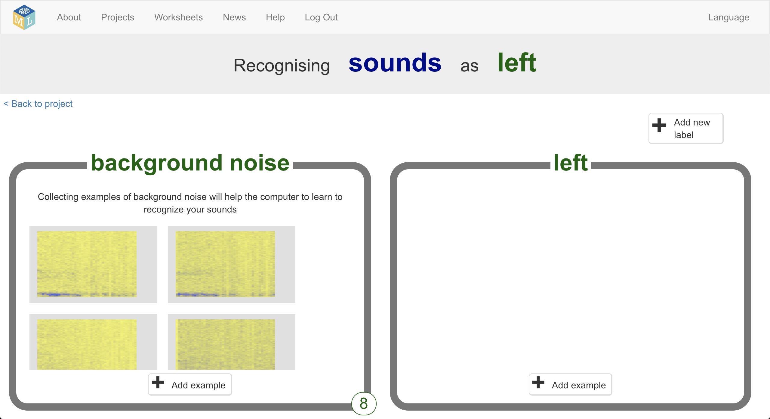
16. Record **at least 8** examples of your alien noise for “left”  
    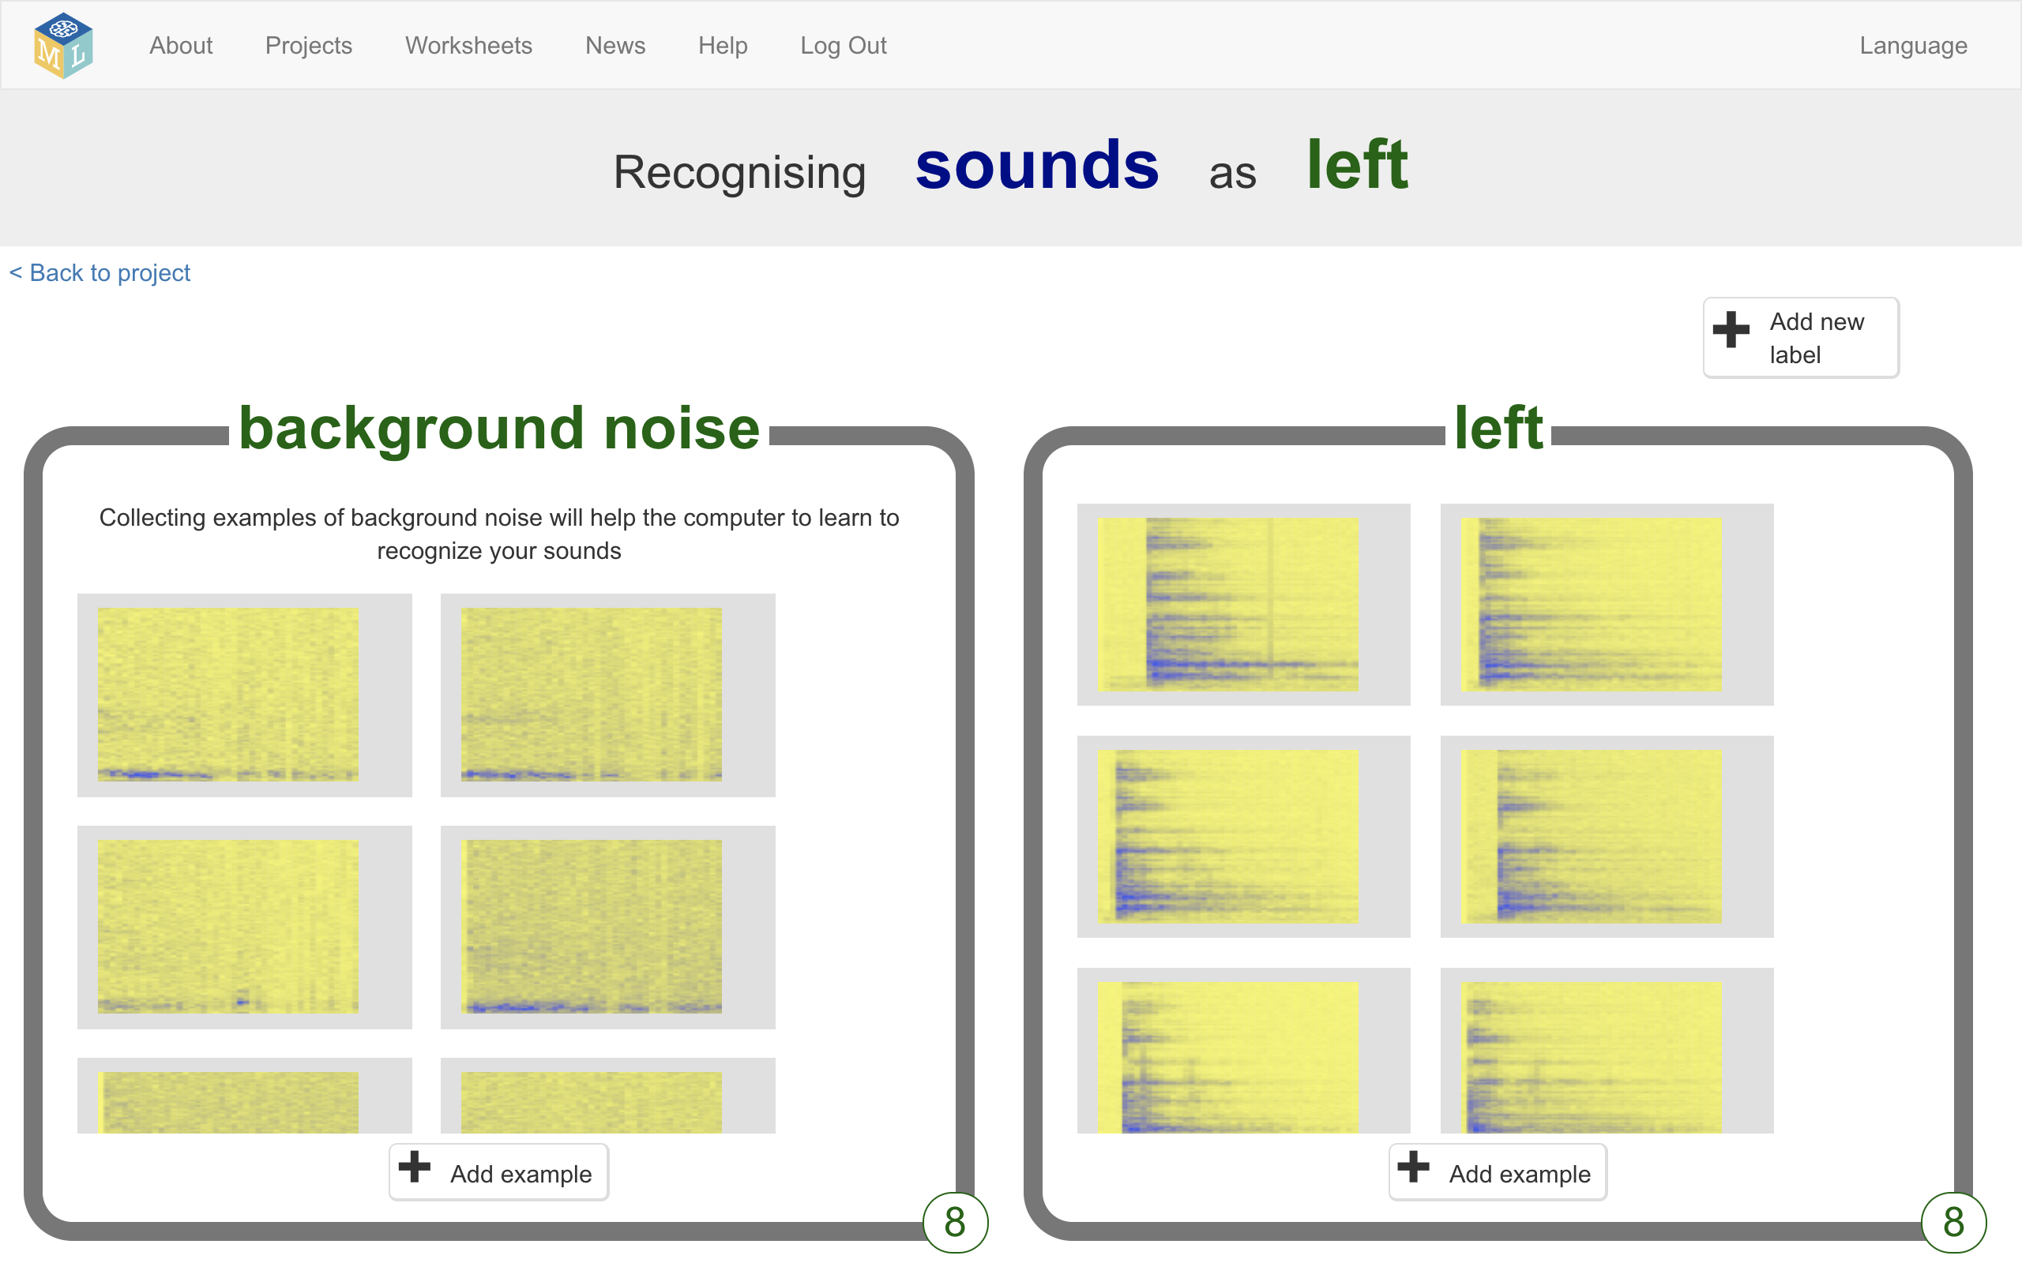
17. Click the **Add new label** button in the top right, and create a new training bucket called “right”
18. Record **at least 8** examples of your alien noise for “right”  
    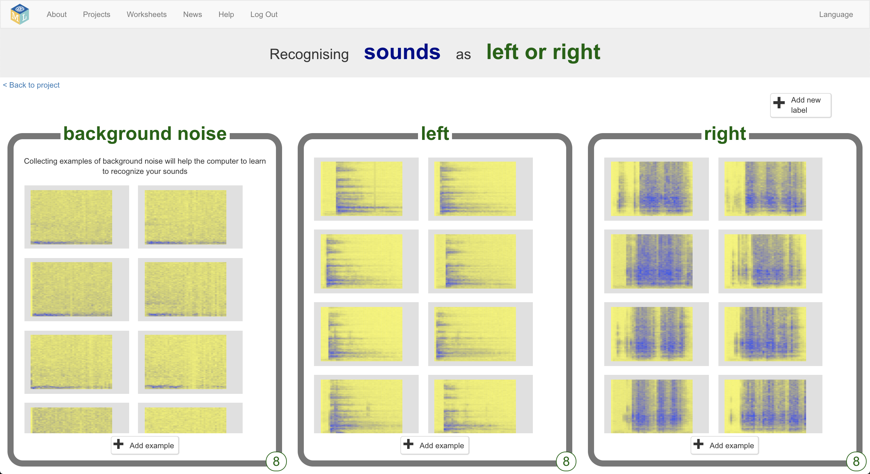
19. Click the “**Back to project**” link in the top left
20. Click the **Learn & Test** button  
    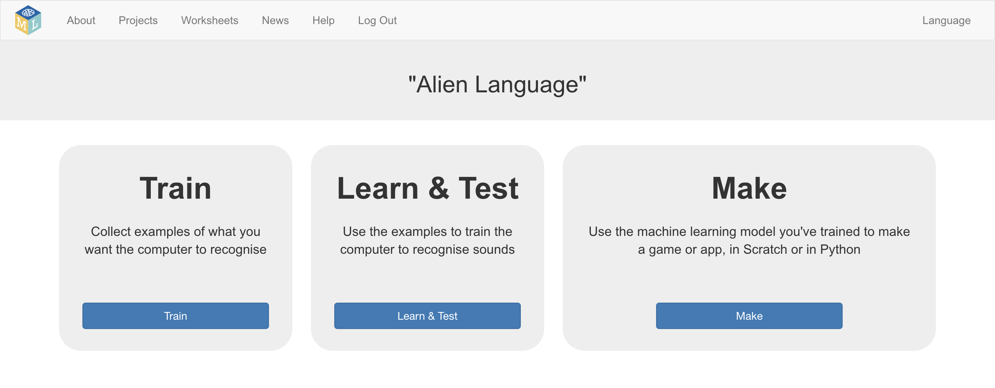
21. Click “**Train new machine learning model**”  
    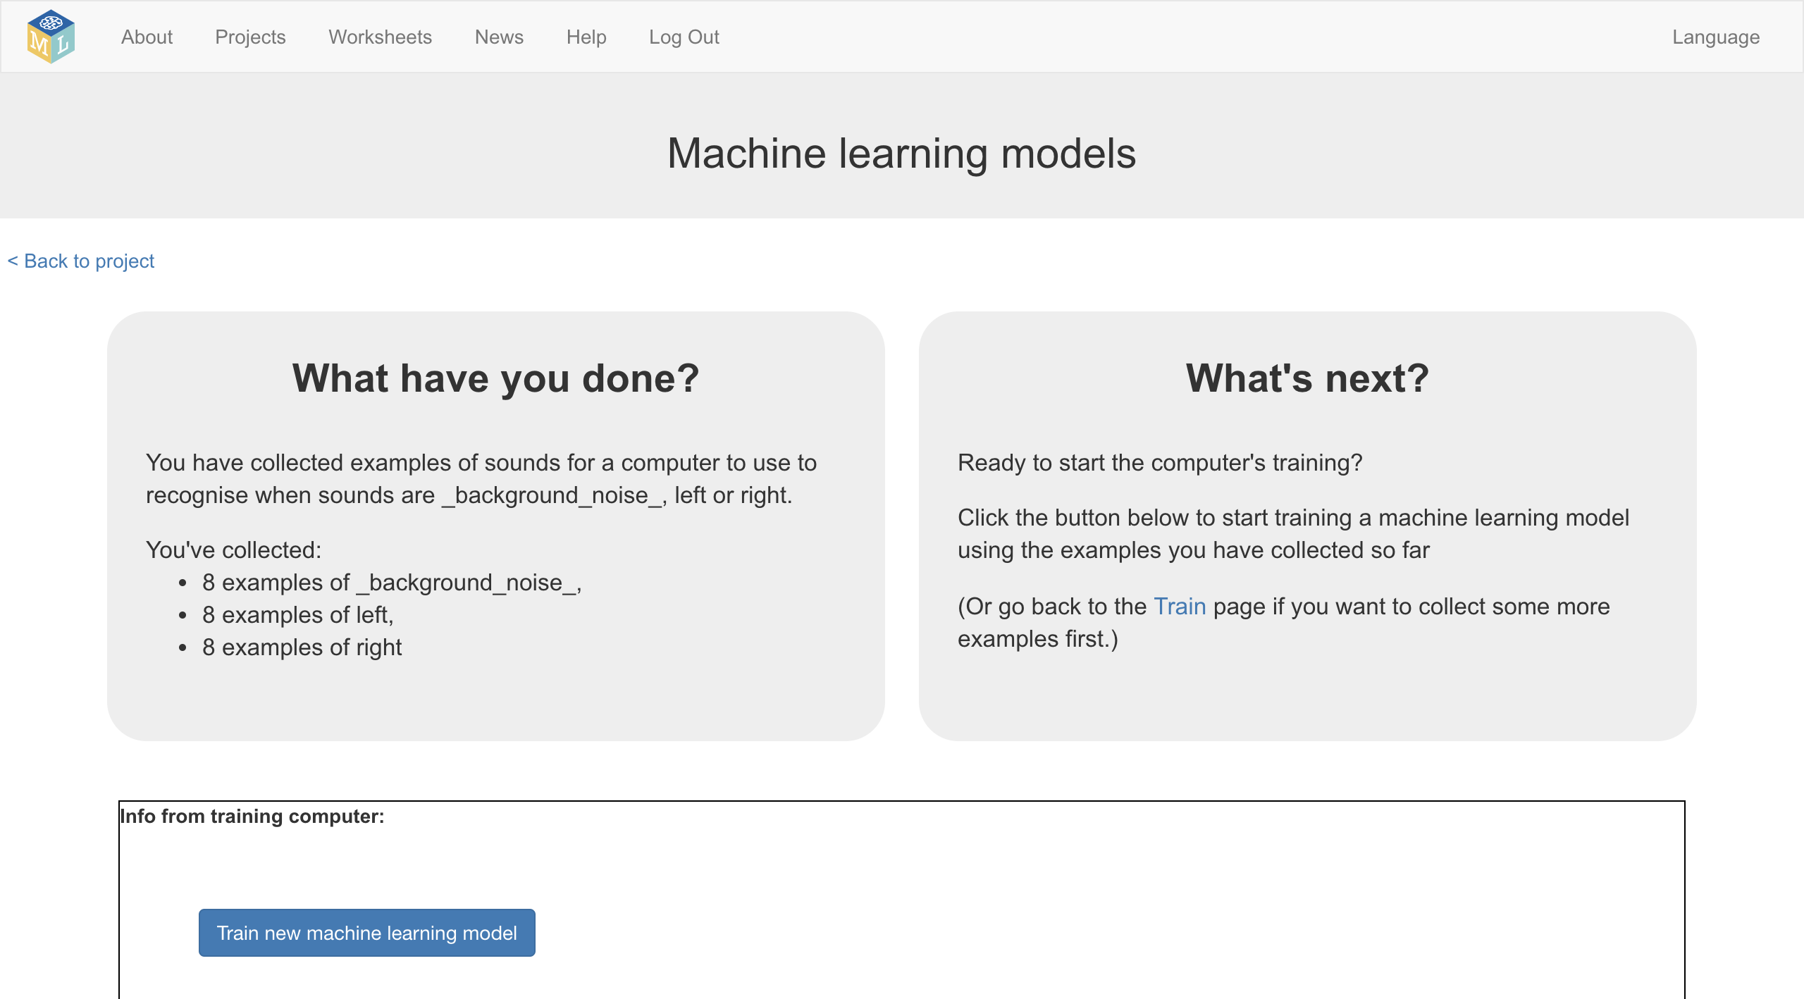
22. Once the training is finished, click the **Start listening** button to test your machine learning model  
    *Make one of the sounds you’ve trained the computer to recognize as meaning “left” or “right”. If your machine learning model recognizes it, it will display what it thinks you did.*  
    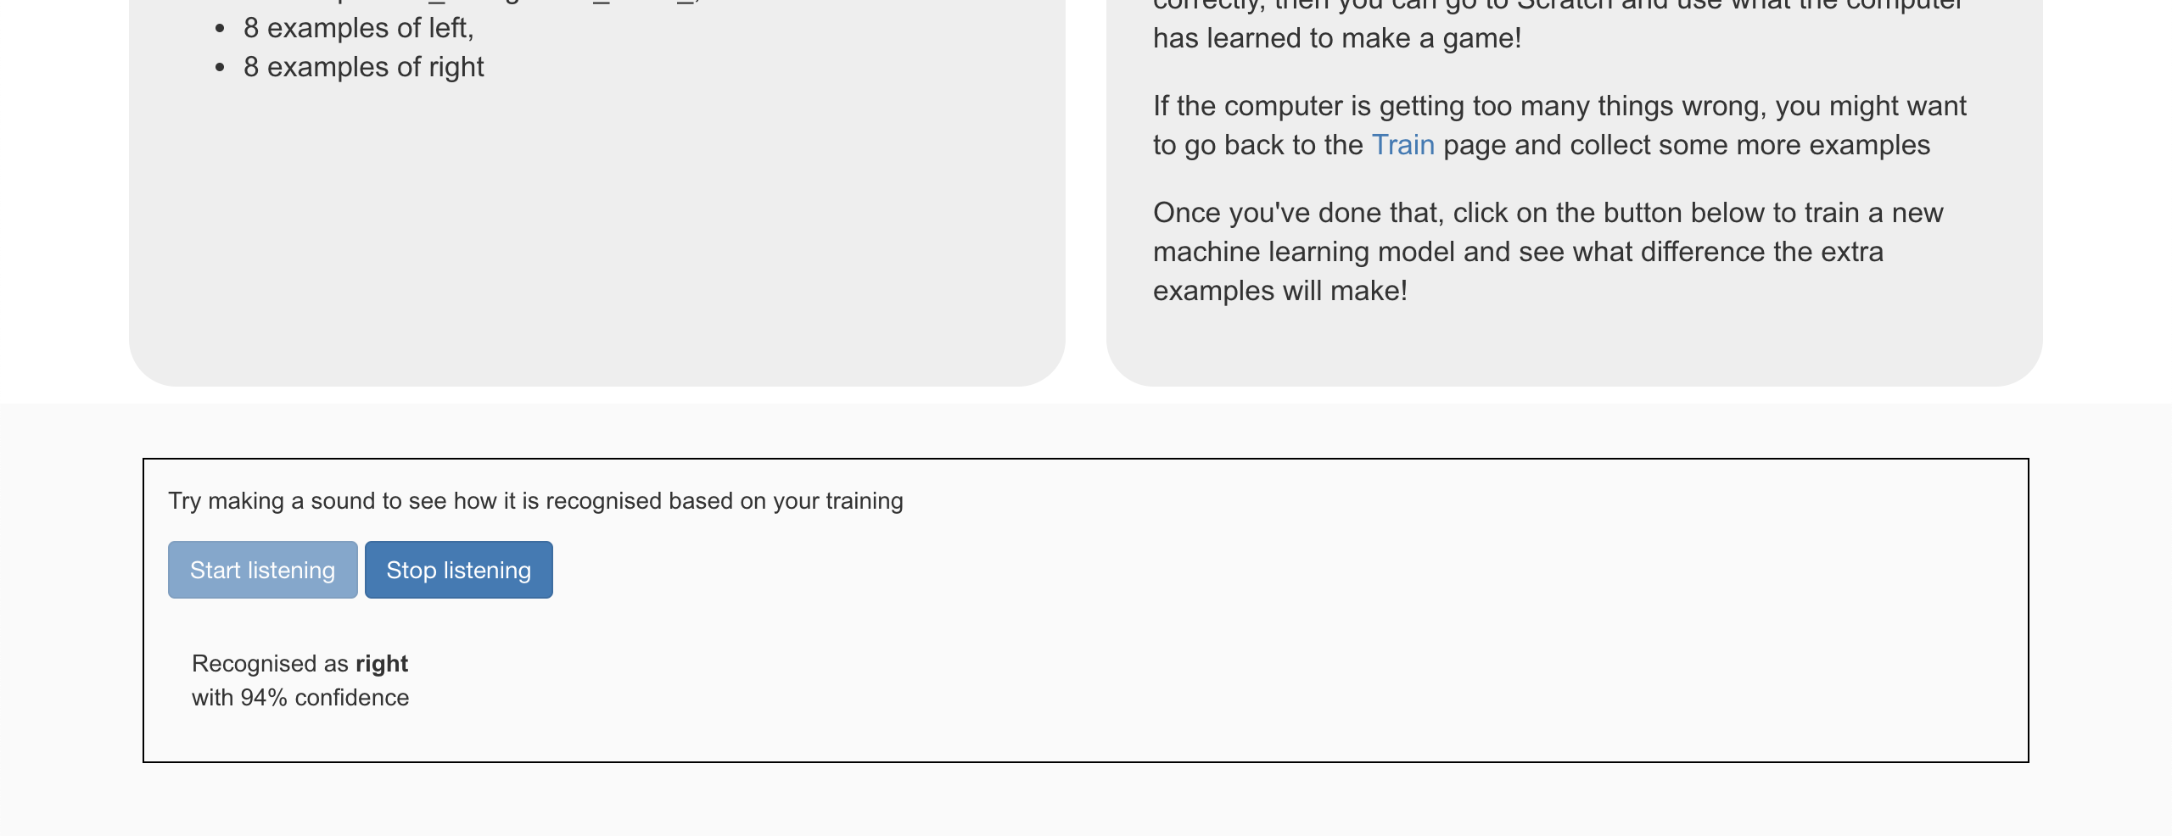
23. If you’re not happy with how the model is working, go back to the **Train** page and add more examples to all three training buckets.
24. When you’re happy with your machine learning model, click on the **Make** button  
    
25. Click on the **Scratch 3** button and then click **Open in Scratch 3**
26. Click on the **Project templates** button at the top of the screen and open the “Alien Language” project template
27. Add the following script to the **alien** sprite  
    *There are already some scripts in the alien sprite to put it in the right place at the start and animate how it walks.* ***Don’t*** *delete these.  
    You can add these scripts underneath them.*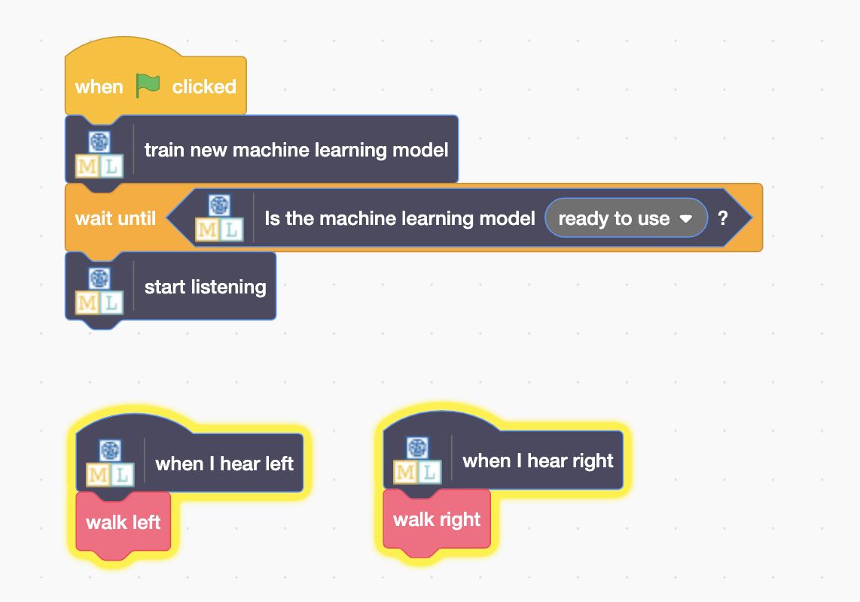
28. It’s time to test! Click the **Green Flag***Make your noises for “left” and “right” to tell the alien which way to walk.*   
    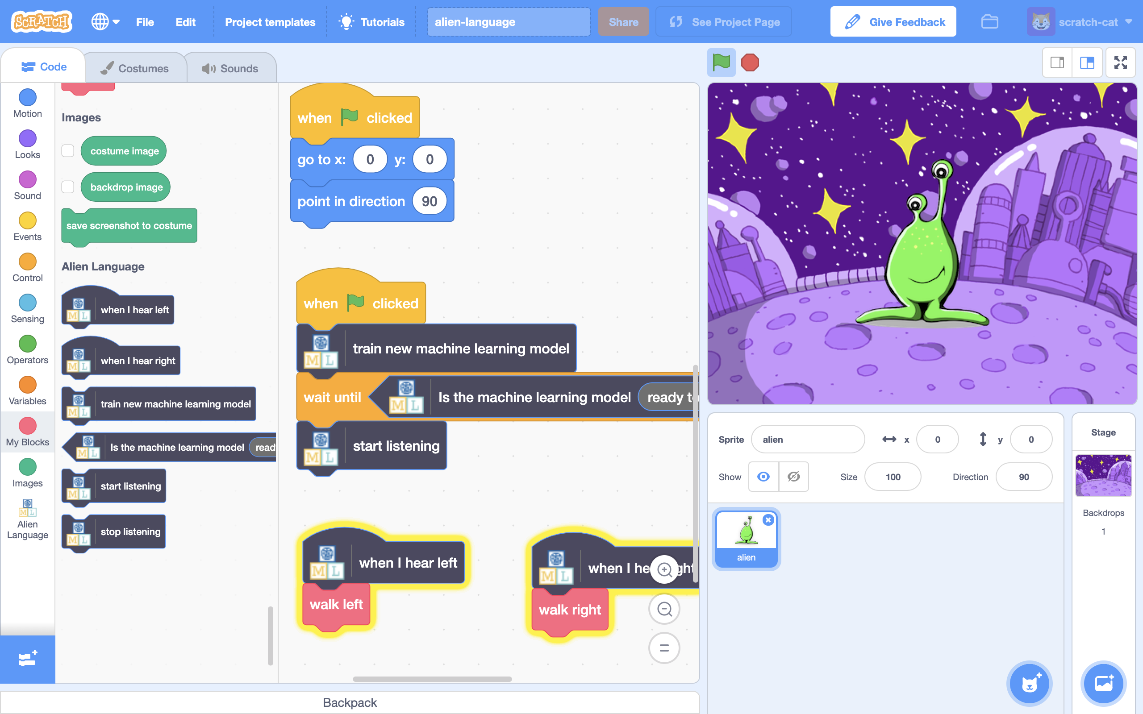

**What have you done?**

You’ve trained your own machine learning model to do speech recognition. You used that to control a character in Scratch.

Unlike the pre-trained model you used before, which has been trained to recognize tens of thousands of words, you’ve only trained it to recognize two different words. But the principle is the same.

You’ve also seen the importance of training the machine learning model to work with a certain background noise.

Can you think of an example of a system like this you’ve seen used before? For example, some cars use speech recognition systems that have been trained to recognize the different commands you can give to the in-car computer. What other examples have you used?

**Ideas and Extensions**

Now that you’ve finished, why not give one of these ideas a try?

Or come up with one of your own?

**Add new commands**

Try adding two more training buckets for “up” and “down” so you can control the alien to move in all four directions.